ID | Name
20230382 | Marwan Hussein Mohamed
20230215 | Abdelrahman Sayed
20230603 | Mahmoud Abdelaziz Mahmoud
20230598 | Ahmed Mohamed Mahmoud
20230223 | Abdullah Ibrahim Fathy
GitHub Repo: Abd-elrahman10/DWH-E-Commerce-Project

Data Warehouse Project Documentation

- Physical model of the source system
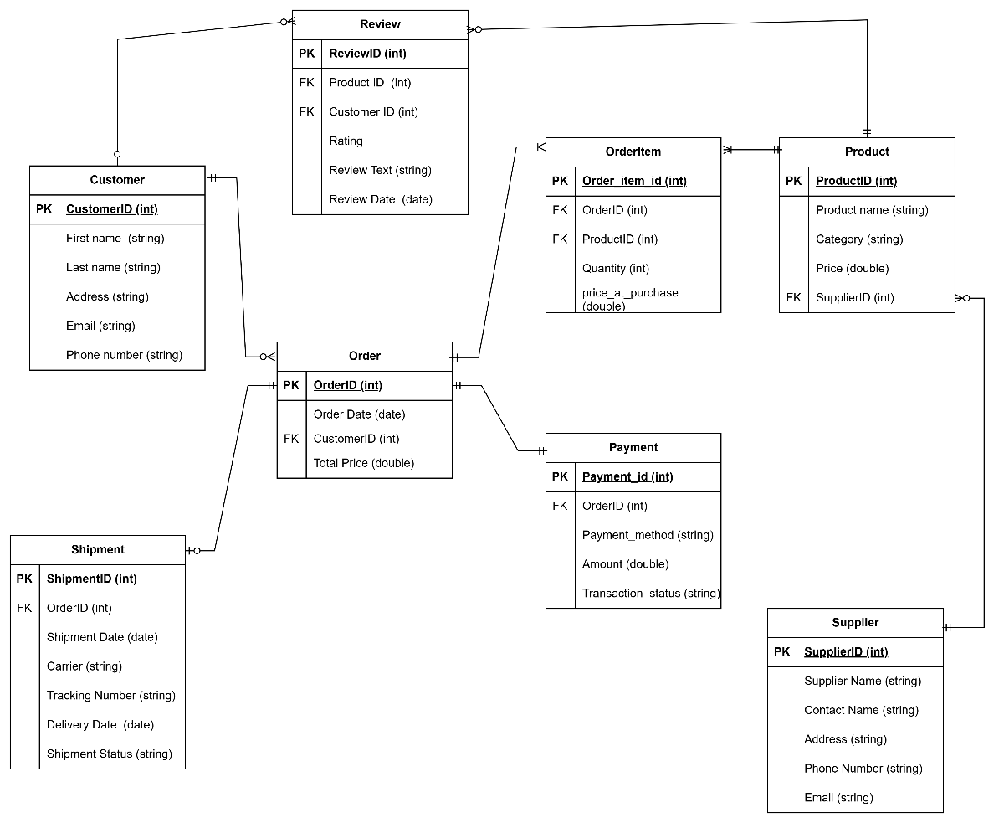

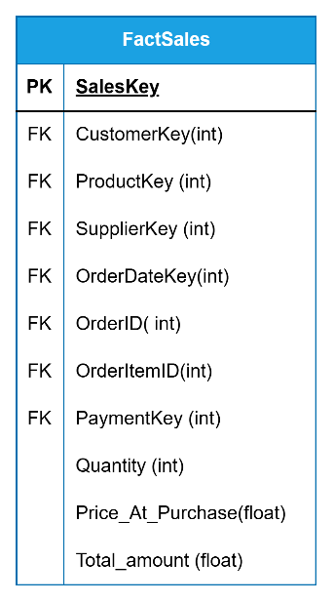
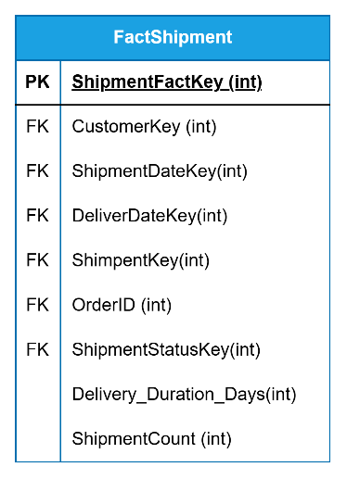
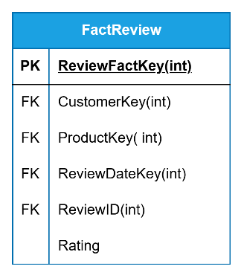
- Fact Tables — Grain & Type

1.1 Fact_Sales
•Grain: Each row in Fact_Sales represents one product line item within one customer order, recorded at the time of purchase.
•Type: Transactional
•Description: The Fact_Sales table captures every product sold in every order. Since one order can contain multiple products, each product in an order generates a separate row in this fact table. This allows detailed analysis of individual product sales, quantities, and revenue.

1.2 Fact_Shipment
•Grain: Each row in Fact_Shipment represents one shipment associated with one order, tracking the shipment from dispatch to delivery.
•Type: Accumulating Snapshot
•Description: The Fact_Shipment table tracks the lifecycle of each shipment from the moment it is dispatched until it is delivered to the customer. It records both the shipment date and the delivery date, allowing calculation of delivery duration and identification of late deliveries.

1.3 Fact_Review
•Grain: Each row in Fact_Review represents one review written by one customer for one product.
•Type: Transactional
•Description: The Fact_Review table captures customer feedback for products they have purchased. Each review is recorded as a separate row, containing the rating given by the customer and the date the review was submitted.

2. Dimension Tables — Types & Descriptions

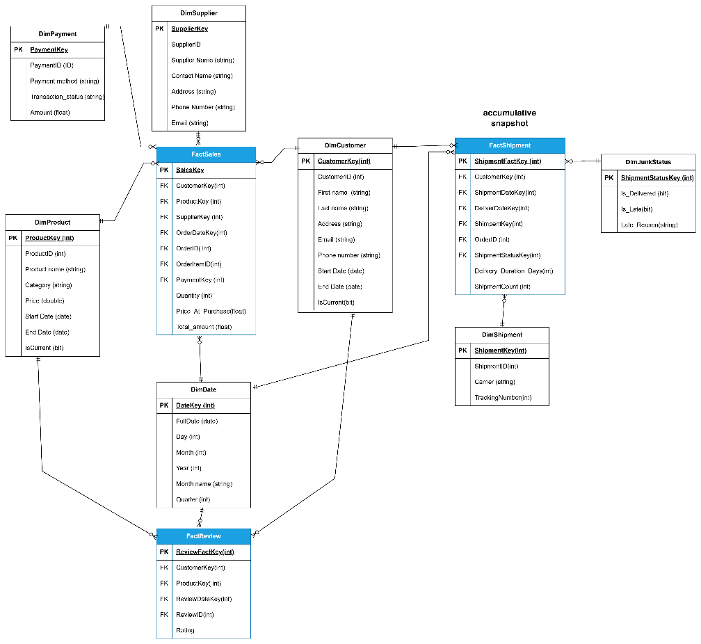

2.1 DimDate — Conformed
•Description: The DimDate dimension contains one row for every date between 2020 and 2030. Since dates never change, this dimension uses Type 0, meaning no updates are ever applied. It allows analysis of all facts by day, month, quarter, and year.
Column | Description
DateKey | Surrogate key in format YYYYMMDD
FullDate | Complete date value
Day | Day number of the month
Month | Month number
Year | Year number
Month_Name | Full month name
Quarter | Quarter number (1-4)

2.2 DimCustomer — Type 2 (Track History)
•Description: The DimCustomer dimension stores customer information. Since customer details such as address and email can change over time, Type 2 is applied to preserve the full history of changes. Each time a customer's information changes, the old record is expired and a new record is inserted.
Column | Description
CustomerKey | Surrogate key
CustomerID | Natural key from source
First_Name | Customer first name
Last_Name | Customer last name
Address | Customer address
Email | Customer email
Phone_Number | Customer phone
Start_Date | Date record became active
End_Date | Date record was expired
IsCurrent | 1 = current, 0 = historical

2.3 DimProduct — Type 2 (Track History)
•Description: The DimProduct dimension stores product information. Since product prices and categories can change over time, Type 2 is applied to preserve historical pricing. This ensures that sales records always reference the correct price at the time of purchase.
Column | Description
ProductKey | Surrogate key
ProductID | Natural key from source
Product_Name | Product name
Category | Product category
Price | Product price
Start_Date | Date record became active
End_Date | Date record was expired
IsCurrent | 1 = current, 0 = historical

2.4 DimSupplier — Type 1 (Overwrite)
•Description: The DimSupplier dimension stores supplier information. Since historical tracking of supplier changes is not required for analysis, Type 1 is applied, meaning any changes to supplier information simply overwrite the existing record.
Column | Description
SupplierKey | Surrogate key
SupplierID | Natural key from source
Supplier_Name | Supplier company name
Contact_Name | Contact person name
Address | Supplier address
Phone_Number | Supplier phone
Email | Supplier email

2.5 DimPayment — Type 1 (Overwrite)
•Description: The DimPayment dimension stores payment method and transaction status information. Since historical tracking of payment method changes is not required, Type 1 is applied.
Column | Description
PaymentKey | Surrogate key
OrderID | Natural key from source
Payment_Method | Payment method used
Transaction_Status | Completed, Pending, or Failed

2.6 DimShipment — Type 1 (Overwrite)
•Description: The DimShipment dimension stores carrier and tracking information for each shipment. Type 1 is applied since historical tracking of carrier changes is not required.
Column | Description
ShipmentKey | Surrogate key
ShipmentID | Natural key from source
Carrier | Shipping carrier name
Tracking_Number | Shipment tracking number

2.7 DimJunkStatus — Conformed
•Description: The DimJunkStatus dimension is a junk dimension that combines shipment status flags into a single dimension table. It contains all possible combinations of Is_Delivered, Is_Late, and Late_Reason. Since these combinations are pre-defined and never change, Type 0 is applied.
Column | Description
ShipmentStatusKey | Surrogate key
Is_Delivered | 1 = Delivered, 0 = Not Delivered
Is_Late | 1 = Late, 0 = On Time
Late_Reason | Reason for late delivery

3. Analytical Queries and Insights
Query 1 — Total Revenue
SELECT
SUM(f.Total_Amount) AS Total_Revenue
FROM Fact_Sales f
JOIN DimPayment p ON f.PaymentKey = p.PaymentKey
WHERE p.Transaction_Status = 'Completed'

Query 2 — Revenue by Month and Year
SELECT
d.Year,
d.Month_Name,
SUM(f.Total_Amount) AS Monthly_Revenue,
COUNT(DISTINCT f.OrderID) AS Total_Orders
FROM Fact_Sales f
JOIN DimDate d ON f.OrderDateKey = d.DateKey
JOIN DimPayment p ON f.PaymentKey = p.PaymentKey
WHERE p.Transaction_Status = 'Completed'
GROUP BY d.Year, d.Month_Name, d.Month
ORDER BY d.Year, d.Month

Query 3 — Revenue by Product
SELECT
p.Product_Name,
p.Category,
SUM(f.Total_Amount) AS Revenue,
SUM(f.Quantity) AS Units_Sold
FROM Fact_Sales f
JOIN DimProduct p ON f.ProductKey = p.ProductKey
JOIN DimPayment py ON f.PaymentKey = py.PaymentKey
WHERE py.Transaction_Status = 'Completed'
AND p.IsCurrent = 1
GROUP BY p.Product_Name, p.Category
ORDER BY Revenue DESC

Query 4 — Top 10 Best Selling Products
SELECT TOP 10
p.Product_Name,
p.Category,
SUM(f.Quantity) AS Units_Sold,
SUM(f.Total_Amount) AS Revenue
FROM Fact_Sales f
JOIN DimProduct p ON f.ProductKey = p.ProductKey
WHERE p.IsCurrent = 1
GROUP BY p.Product_Name, p.Category
ORDER BY Units_Sold DESC

Query 5 — Average Delivery Time per Carrier
SELECT
s.Carrier,
AVG(f.Delivery_Duration_Days) AS Avg_Delivery_Days,
MIN(f.Delivery_Duration_Days) AS Min_Days,
MAX(f.Delivery_Duration_Days) AS Max_Days,
SUM(f.Shipment_Count) AS Total_Shipments
FROM Fact_Shipment f
JOIN DimShipment s ON f.ShipmentKey = s.ShipmentKey
GROUP BY s.Carrier
ORDER BY Avg_Delivery_Days ASC

Query 6— Average Product Rating
SELECT
p.Product_Name,
p.Category,
AVG(CAST(f.Rating AS FLOAT)) AS Avg_Rating,
COUNT(*) AS Total_Reviews
FROM Fact_Review f
JOIN DimProduct p ON f.ProductKey = p.ProductKey
WHERE p.IsCurrent = 1
GROUP BY p.Product_Name, p.Category
ORDER BY Avg_Rating DESC

Query 7— Top 10 Best Rated Products
SELECT TOP 10
p.Product_Name,
p.Category,
AVG(CAST(f.Rating AS FLOAT)) AS Avg_Rating,
COUNT(*) AS Total_Reviews
FROM Fact_Review f
JOIN DimProduct p ON f.ProductKey = p.ProductKey
WHERE p.IsCurrent = 1
GROUP BY p.Product_Name, p.Category
HAVING COUNT(*) >= 5
ORDER BY Avg_Rating DESC

4. Using SSIS in VS [Staging Area]:
4.1: ETL to Staging Area
Control Flow:
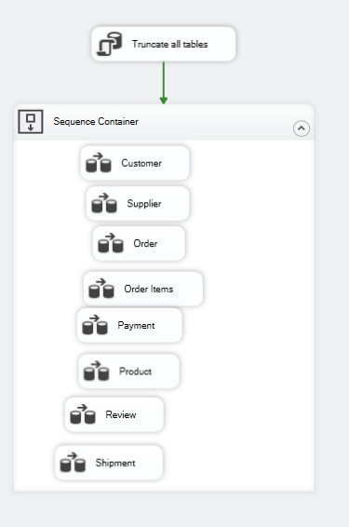

Data Flow:
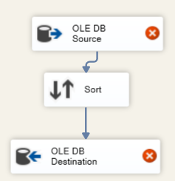

4.2 ETL to DWH
Control Flow
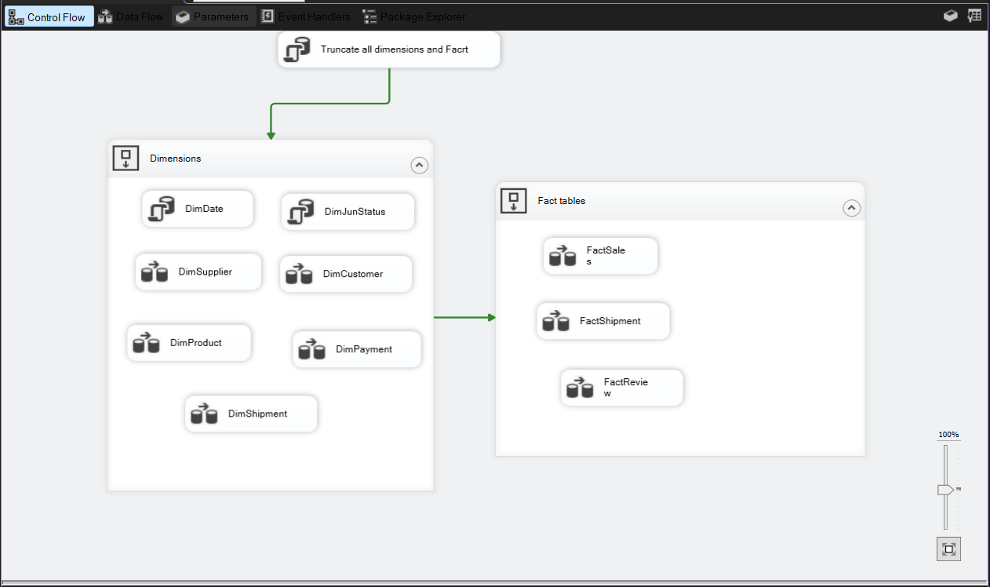

Data Flow
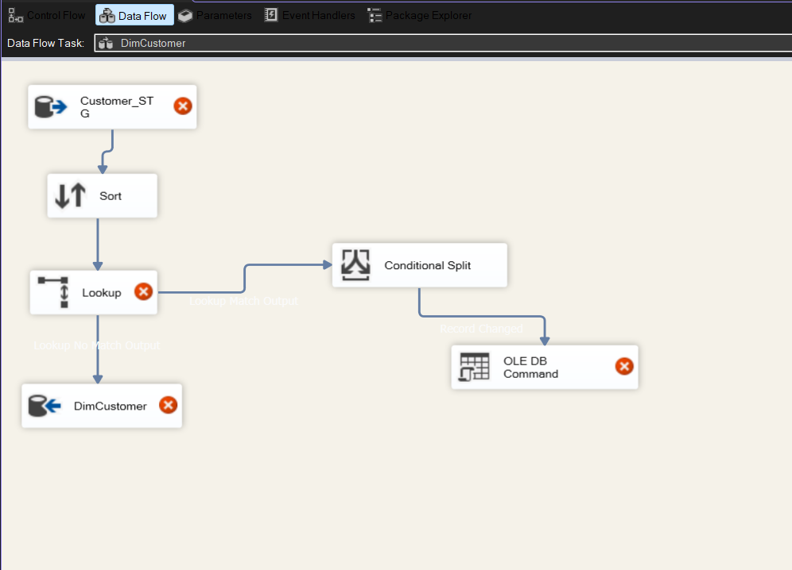

5. Deployment
1. Success of deployment
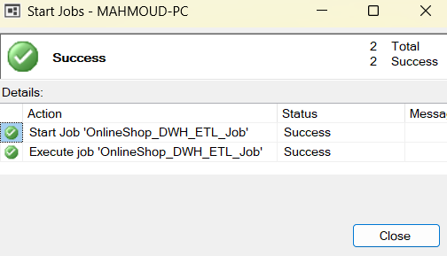

2. Integration Server Catalogs details in the SSMS explorer.
And showing that all packages (that transfer from the staging to the main DWH) is succeeded
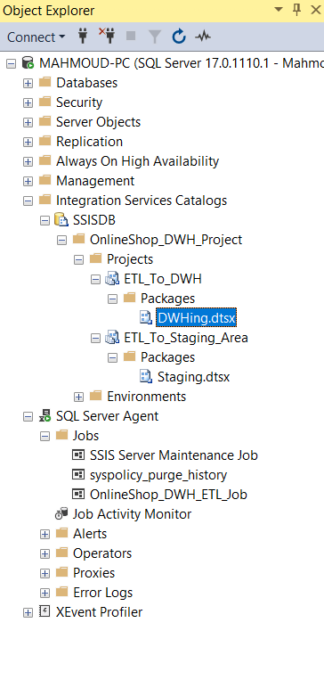
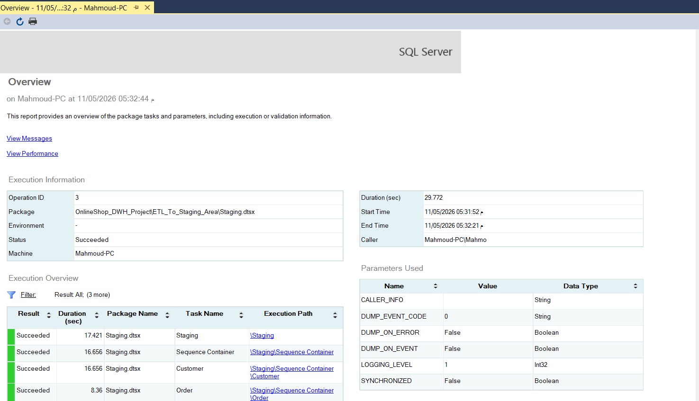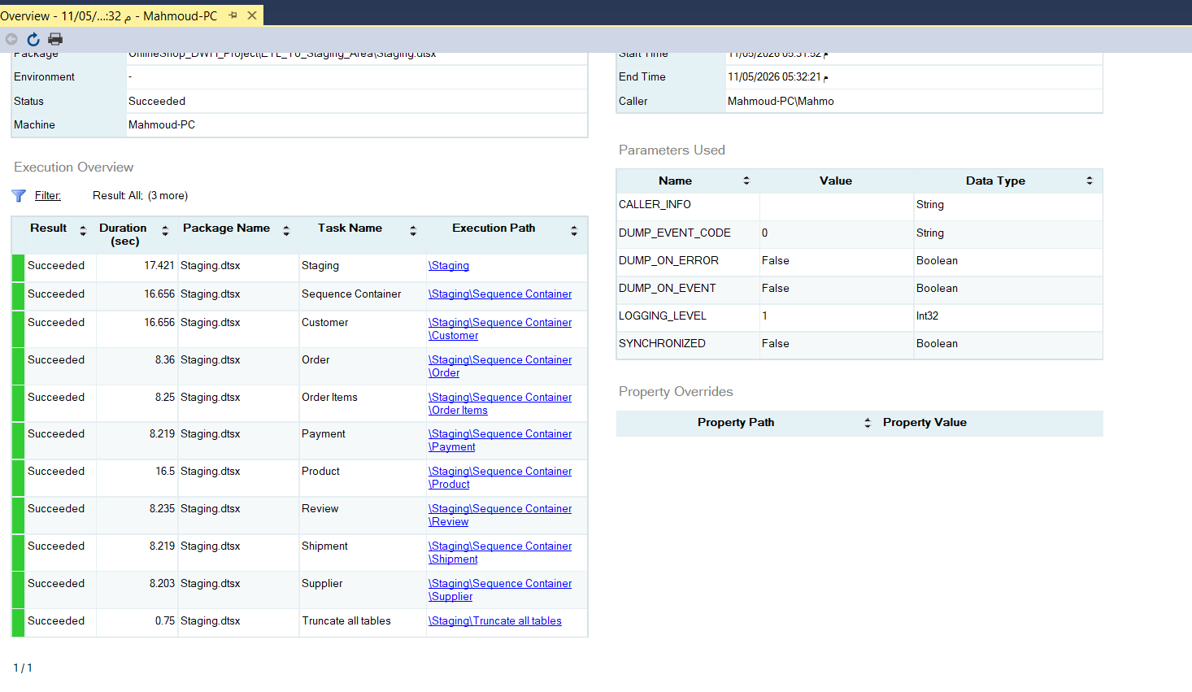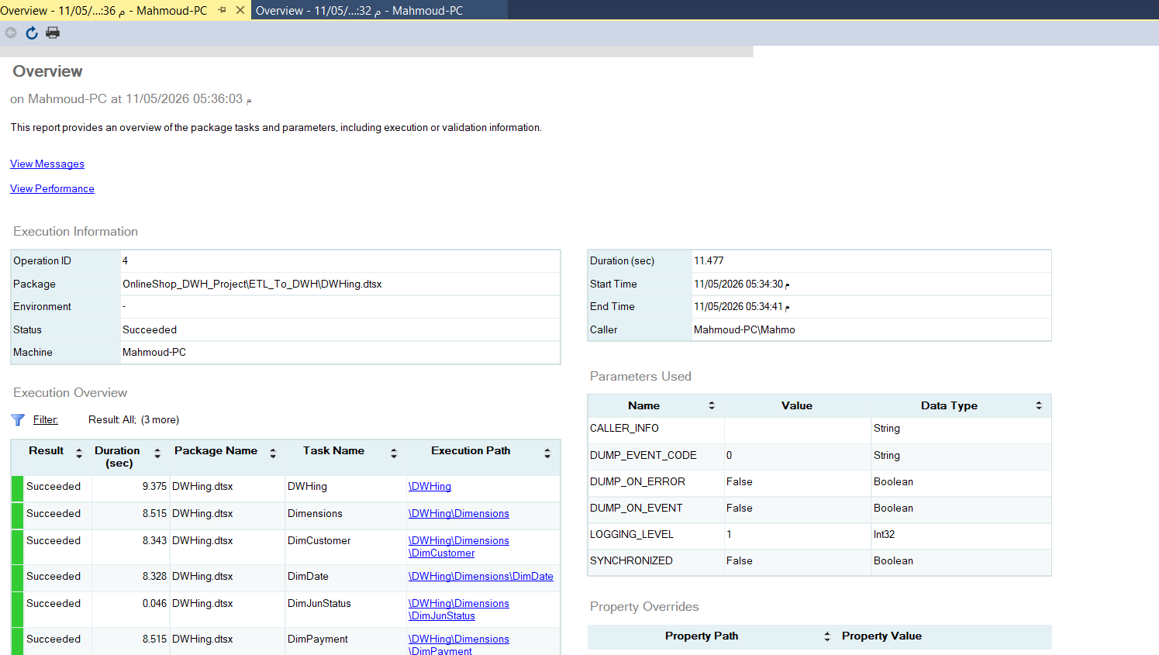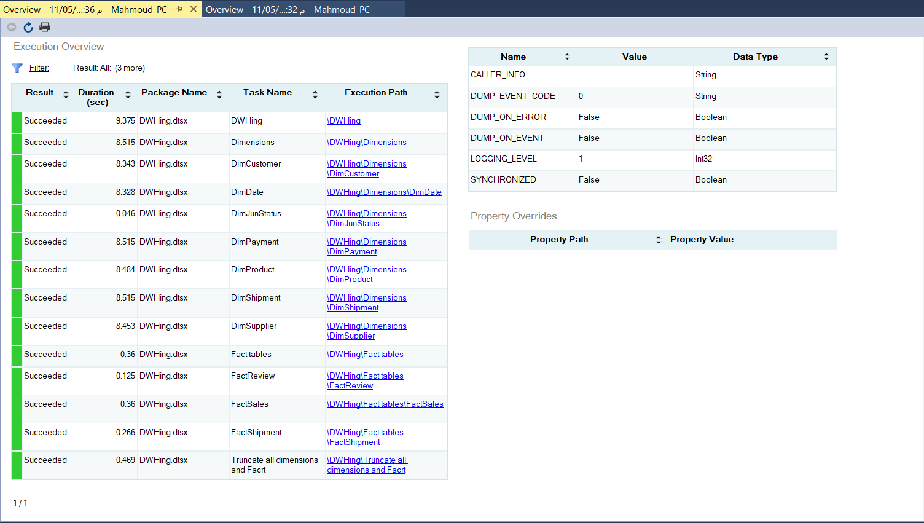

Some properties when success and failure procedures of main processes [data transfer source -> staging -> DWH]
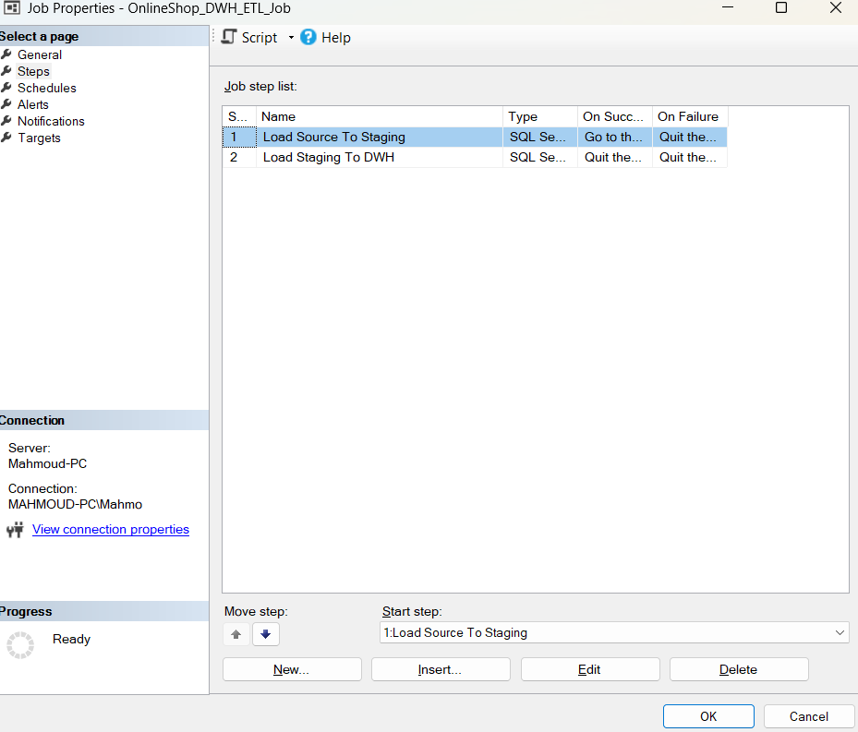
6. Interactive dashboard for the DWH (using Power BI)

